Custom Indexing on Reconciliation Rule Fields
When reconciliation is on, if you receive the following error while creating or importing a CMDB record, raise a case with Salesforce to create custom indexing on the fields that you have used in reconciliation rules.
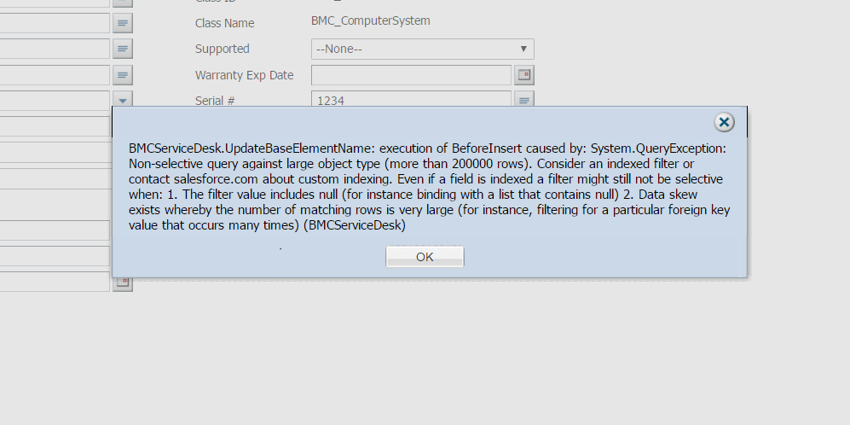
To create custom indexes, share following information with Salesforce:
- Fields to be indexed: Ensure that Salesforce knows which fields to focus on and which fields to ignore. Include all fields used in reconciliation rules.
- SOQL query with bind values: Consider an active reconciliation rule on the Asset #, Serial #, and Assembly ID fields and Filter logic is 1 AND (2 OR 3).
SOQL query formed for this rule:
SELECT Id, Name__c
FROM BMC_BaseElement__c
WHERE (Asset_No__c = <Asset #>
AND (Serial_No__c = <Serial #> OR Assembly_Id__c = <Assembly Id>))
AND MarkAsDeleted__c = false
AND CMDB_Class__c = <Class Id>
Notes:
- If you have created the reconciliation rule on a rule based class, the CMDB_Class__c field is replaced by FKAssetRuleClass__c in the query.
- The “RemedyforceSetting__c” custom setting determines if the value of the Mark as deleted field is True or False. This custom setting has a record named as “CMDB_ReconcileMarkAsDeleted”. If the value of this record set to true, query will not include the line “AND MarkAsDeleted__c = false”.
- Login access: With login access, Salesforce will be able to replicate and understand the issue correctly.
- Error messages/time stamps: Any error logs/time-stamps will help Salesforce in understanding the need for indexing.
- Steps to replicate the error: Ensures that Salesforce follows the same path that you followed to understand the issue.
References:
- https://help.salesforce.com/HTViewSolution?id=000006007&language=en_U
- https://help.salesforce.com/apex/HTViewSolution?urlname=Checklist-for-Custom-Index-Requests&language=en_US

